# Aidan Farrugia CCD6.2A

# CPD

R&U1: Google Accessibility scanner

E&U7: 3 Future updates

1. Landing bay Parked feature: Allows the pilot to log the specific landing bay where the plane was parked at each airport.
2. Photo upload for each destination: Adding an image picker to store an image for the destination.
3. Weather Snapshot Time of Arrival: Automatically capture the weather conditions (temperature, wind, etc.) and stored under each entry.

A&A1: Small, Medium & Large Screen

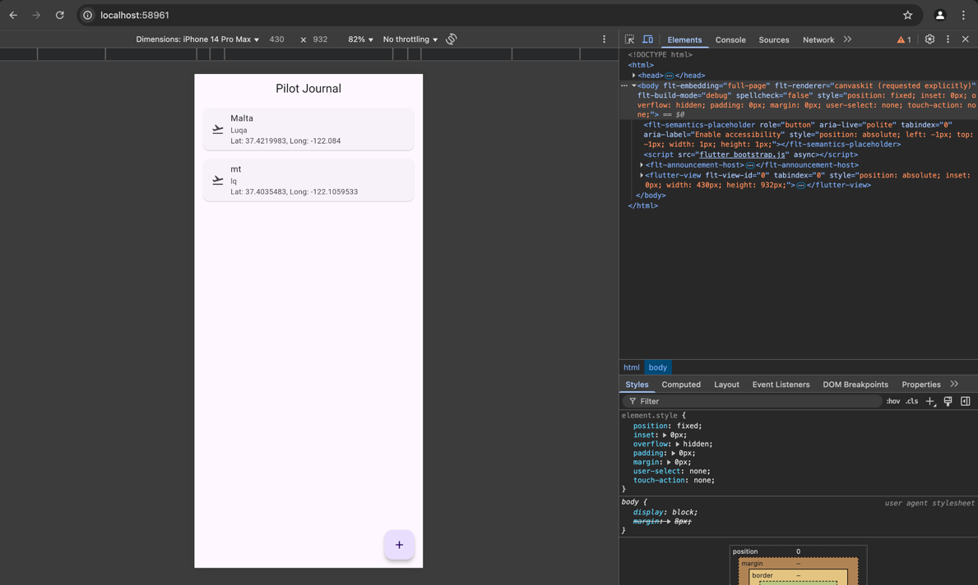

R&U6:Flutter Dev Tools

Debugger: Allowed me to set breakpoints and step through logic like location fetching and Firebase database writes. This helped confirm the app flow and fix any unexpected behavior during runtime.

Flutter Inspector: Helped visualize the widget tree and debug UI layout issues. I used it to check alignment and padding in the list of destinations and ensure the form layout was responsive.

E&U6: Firebase Analytics:

Firebase analytics can collect quite a vast amount of data to show the progression of the app while in use. This can help for further adjustments or even for digital marketing to advertise the product to the potential users.

**Time spent in app** – How long a user spends on the app

**User Demographics such as**: **Age, gender and location** – this will help in having a visual analysis on what type of people use your app.

**Events Tracking –** Button taps etc. to track which features are not used that much to make them better.

**App Performance –** track Crashes and errors or even app start time to analyize any errors or efficiency.

**User Behavior-** The path that the user takes while using the app, or even the point where the user leaves the app and on which page.

**Monetization-** in-app purchases and any add-ons purchased can be tracked

A&A5: Github Actions

GitHub Actions is a CI/CD platform that allows you to automate most things such as Building the app, testing, and any deployment pipelines inside the repository

It can do the following:

1. Automatically build and test the app on every commit
2. Run checks across multiple platforms like android, IOS etc….
3. Deploy the app Firebase, GitHub Pages, or other platforms